**Class Diagram for Room Radar System**

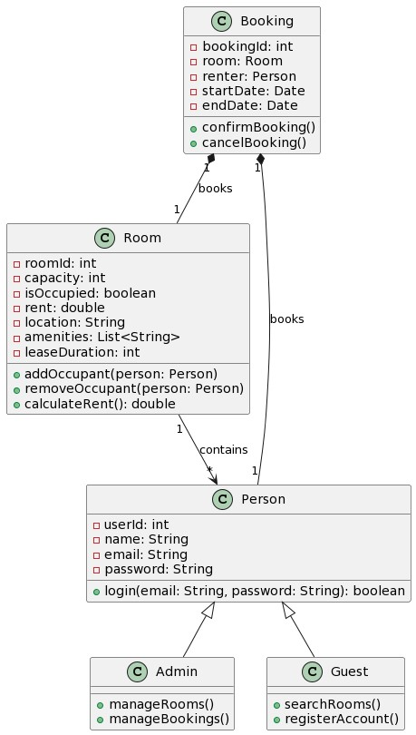

**Use Case Diagram for Room Radar System**

